

Vivekananda Institute of Professional Studies - TC
Vivekananda School of Information Technology



Web Technologies Lab File

Paper Code:
BCA – 175

Course Name:
Web Technologies

Submitted to: Submitted by:
Dr. Anupama Jha Shashank Verma
Assistant Professor Enrollment No:
Subject Faculty 06717702026
VSIT, VIPS-TC BCA – 1B (1^{rst} Shift)

INDEX

S. No | Name of the Program | Date | Signature
1 | Assignment No. 1 | 29.09.2026
2 | Assignment No. 2 | 23.08.2026
3 | Assignment No. 3 | 12.09.2026
4 | Assignment No. 4 | 12.09.2026
5 | Assignment No. 5 | 16.09.2026
6 | Assignment No. 6 | 16.09.2026
7 | Assignment No. 7 | 23.09.2026

Vivekananda School of Information Technology

WT LAB Assignment
Faculty Name: Dr. Anupama Jha

Subject: Web Technologies Lab, BCA 175 BCA 1st Semester

Final 15 Programs

1. | Make 5 different web pages out of which first page is your home page with links to other four pages. The rest of the pages should have following :  i) Formatting styles and headings: include bold, italics, underline, strike, subscript, superscript and all six types of headings  ii) about font styles and image tag.  iii) Marquee: Move text, image and hyperlink.  iv) Other tags: br, hr, pre and p  Include the following specifications:  - In all these webpages only mention about use, attributes apply them.  - Insert a background image on home page.  - Make all the topics as hyperlinks on this page and go to some other page for description  - Insert a marquee showing “HTML TUTORIAL” as moving text.  - Use different font style for different topics  - On every page, make a hyperlink for going back to home page and internal link also. | CO1, CO3
2 | Create an unordered list nested inside ordered list and apply the following:  - Insert an image of Main item on top right corner of web page.  - Display heading as Marquee.  - Use different font styles and colors for different ordered list items.  - Insert Horizontal lines after each ordered item. | CO1, CO3
3. | Design a table with row span and column span and make use of attributes colspan, rowspan, width, height, cellpadding, cellspacing etc. | CO1, CO3
4. | Design the following frame using HTML and CSS:  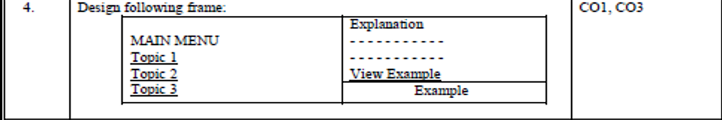  Take Topic 1: Covid-19 and its variants  Topic 2: India in Covid 19  Topic 3: Precautions to be taken in Covid 19 | CO1, CO3
5. | Make an image map showing the usage of shape, cords, href attributes in map. Link each hotspot to their respective details. All the web pages should be designed with proper background color, images, font styles and headings. | CO1, CO3
6 | Design Student Registration Form for admission in college. | CO1, CO3
7 | Create a webpage and show the usage of inline, internal and external stylesheets. | CO1, CO3
8 | Create a webpage containing a background image and apply all the background styling attributes. | CO1, CO3
9 | Create a webpage containing various Bootstrap typography classes. | CO1, CO3
10 | Create a webpage containing various different Glyphicons. | CO1, CO3
11 | Write a program to show the usage of inbuilt functions and dialogue boxes | CO2
12 | Write a program to Implement event handling using onclick, onmouseover and onmouseout events | CO2
13 | Write a Java script program to show the usage of all the date, math and string objects | CO2
14 | WAP to format the Teacher details in XML with CSS using external DTD | CO1, CO3
15 | Design a website and apply all the features of HTML, CSS, Javascript and bootstrap to make website attractive. | CO4

Assignment No.: 1

assignment1/
├── fonts_images.html
├── formatting.html
├── home.html
├── marquee.html
└── other_tags.html

Source Code:

<!-- formatting.html -->
<html>
<head>
<title>Formatting Styles and Headings</title>
</head>
<body>

<h2>1. Formatting Tags</h2>
<p>Use: These tags change how text looks on the page.</p>

<!-- <b> = bold text -->
<p><b>This is bold text</b> — tag used: &lt;b&gt;</p>

<!-- <i> = italic text -->
<p><i>This is italic text</i> — tag used: &lt;i&gt;</p>

<!-- <u> = underlined text -->
<p><u>This is underlined text</u> — tag used: &lt;u&gt;</p>

<!-- <s> = strikethrough text -->
<p><s>This is strikethrough text</s> — tag used: &lt;s&gt;</p>

<!-- <sub> = subscript -->
<p>H<sub>2</sub>O (subscript) — tag used: &lt;sub&gt;</p>

<!-- <sup> = superscript -->
<p>x<sup>2</sup> (superscript) — tag used: &lt;sup&gt;</p>

<hr>

<h2>2. All Six Headings (h1 to h6)</h2>
<p>Use: Headings give structure to a page. h1 is the biggest, h6 is the smallest.</p>

<h1>This is Heading 1 (h1)</h1>
<h2>This is Heading 2 (h2)</h2>
<h3>This is Heading 3 (h3)</h3>
<h4>This is Heading 4 (h4)</h4>
<h5>This is Heading 5 (h5)</h5>
<h6>This is Heading 6 (h6)</h6>

<hr>

<!-- Internal link: jumps to a bookmark on the same page -->
<h3 id="bottom">You have reached the bottom of this page</h3>
<p><a href="#bottom">Jump to bottom (internal link)</a></p>

<p><a href="home.html">Back to Home Page</a></p>

</body>
</html>

<!-- fonts_images.html -->
<html>
<head>
<title>Font Styles and Image Tag</title>
</head>
<body>

<h2>1. Font Styles</h2>
<p>Use: The style attribute (with font-family, font-size, color) controls how text is displayed.</p>

<p style="font-family:Arial; font-size:18px; color:blue;">
This text uses Arial font, size 18px, blue color.
</p>

<p style="font-family:'Times New Roman'; font-size:20px; color:green;">
This text uses Times New Roman font, size 20px, green color.
</p>

<p style="font-family:'Courier New'; font-size:16px; color:brown;">
This text uses Courier New font, size 16px, brown color.
</p>

<hr>

<h2>2. Image Tag</h2>
<p>Use: The &lt;img&gt; tag is used to display an image on a web page. It has no closing tag.</p>
<p>Attributes used below: src (image path), alt (text if image not found), width, height.</p>

<img src="sample.jpg" alt="Sample Image" width="300" height="200">

<hr>

<p><a href="home.html">Back to Home Page</a></p>

</body>
</html>

<!-- marquee.html -->
<html>
<head>
<title>Marquee Examples</title>
</head>
<body>

<h2>Marquee Tag</h2>
<p>Use: The &lt;marquee&gt; tag makes its content move automatically (scroll/slide/bounce).</p>
<p>Attributes used: behavior, direction.</p>

<h3>1. Moving Text</h3>
<marquee behavior="scroll" direction="left">
This text is moving from right to left!
</marquee>

<h3>2. Moving Image</h3>
<marquee behavior="alternate" direction="right">
<img src="sample.jpg" alt="Moving Image" width="150" height="100">
</marquee>

<h3>3. Moving Hyperlink</h3>
<marquee behavior="scroll" direction="up">
<a href="home.html">Click here to go Home (this link is moving)</a>
</marquee>

<hr>

<p><a href="home.html">Back to Home Page</a></p>

</body>
</html>

<!-- other_tags.html -->
<html>
<head>
<title>Other Tags: br, hr, pre, p</title>
</head>
<body>

<h2>1. &lt;p&gt; Tag</h2>
<p>Use: The &lt;p&gt; tag defines a paragraph. Browsers automatically add space before and after it.</p>
<p>This is one paragraph.</p>
<p>This is another, separate paragraph.</p>

<hr>

<h2>2. &lt;br&gt; Tag</h2>
<p>Use: The &lt;br&gt; tag inserts a single line break. It has no closing tag.</p>
<p>
Roses are red,<br>
Violets are blue,<br>
HTML is fun,<br>
And so are you!
</p>

<hr>

<h2>3. &lt;hr&gt; Tag</h2>
<p>Use: The &lt;hr&gt; tag draws a horizontal line, often used to separate sections.</p>
<p>Above and below this line is content separated by &lt;hr&gt;.</p>
<hr>
<p>See? A line was drawn above.</p>

<hr>

<h2>4. &lt;pre&gt; Tag</h2>
<p>Use: The &lt;pre&gt; tag displays text exactly as written — keeping spaces and line breaks.</p>
<pre>
function greet() {
console.log("Hello, World!");
}
</pre>

<hr>

<p><a href="home.html">Back to Home Page</a></p>

</body>
</html>

<!-- home.html -->
<html>

<head>
<title>Home Page - HTML Tutorial</title>
</head>

<body background="bg.jpg" bgcolor="#dff3ff" style="background-size:cover;">

<center>
<h1 style="color:darkblue;">Welcome to My HTML Tutorial Website</h1>

<!-- Marquee showing moving text -->
<marquee behavior="scroll" direction="left" bgcolor="#cccccc" style="color:red; font-size:20px;">
HTML TUTORIAL
</marquee>

<h3>Click on a topic below to learn more (each topic uses a different font style):</h3>

<!-- Each link uses a different font style via inline CSS -->
<p><a href="formatting.html" style="font-family:'Times New Roman'; font-size:18px;">1. Formatting Styles and
Headings</a></p>

<p><a href="fonts_images.html" style="font-family:'Courier New'; font-size:18px;">2. Font Styles and Image
Tag</a></p>

<p><a href="marquee.html" style="font-family:'Georgia'; font-size:18px;">3. Marquee (Moving Text, Image,
Link)</a></p>

<p><a href="other_tags.html" style="font-family:'Verdana'; font-size:18px;">4. Other Tags: br, hr, pre, p</a>
</p>

<p><br>Shashank Kumar Verma / 06717702026 / BCA (1B) / 1rst Sem</p>
</center>

</body>

</html>

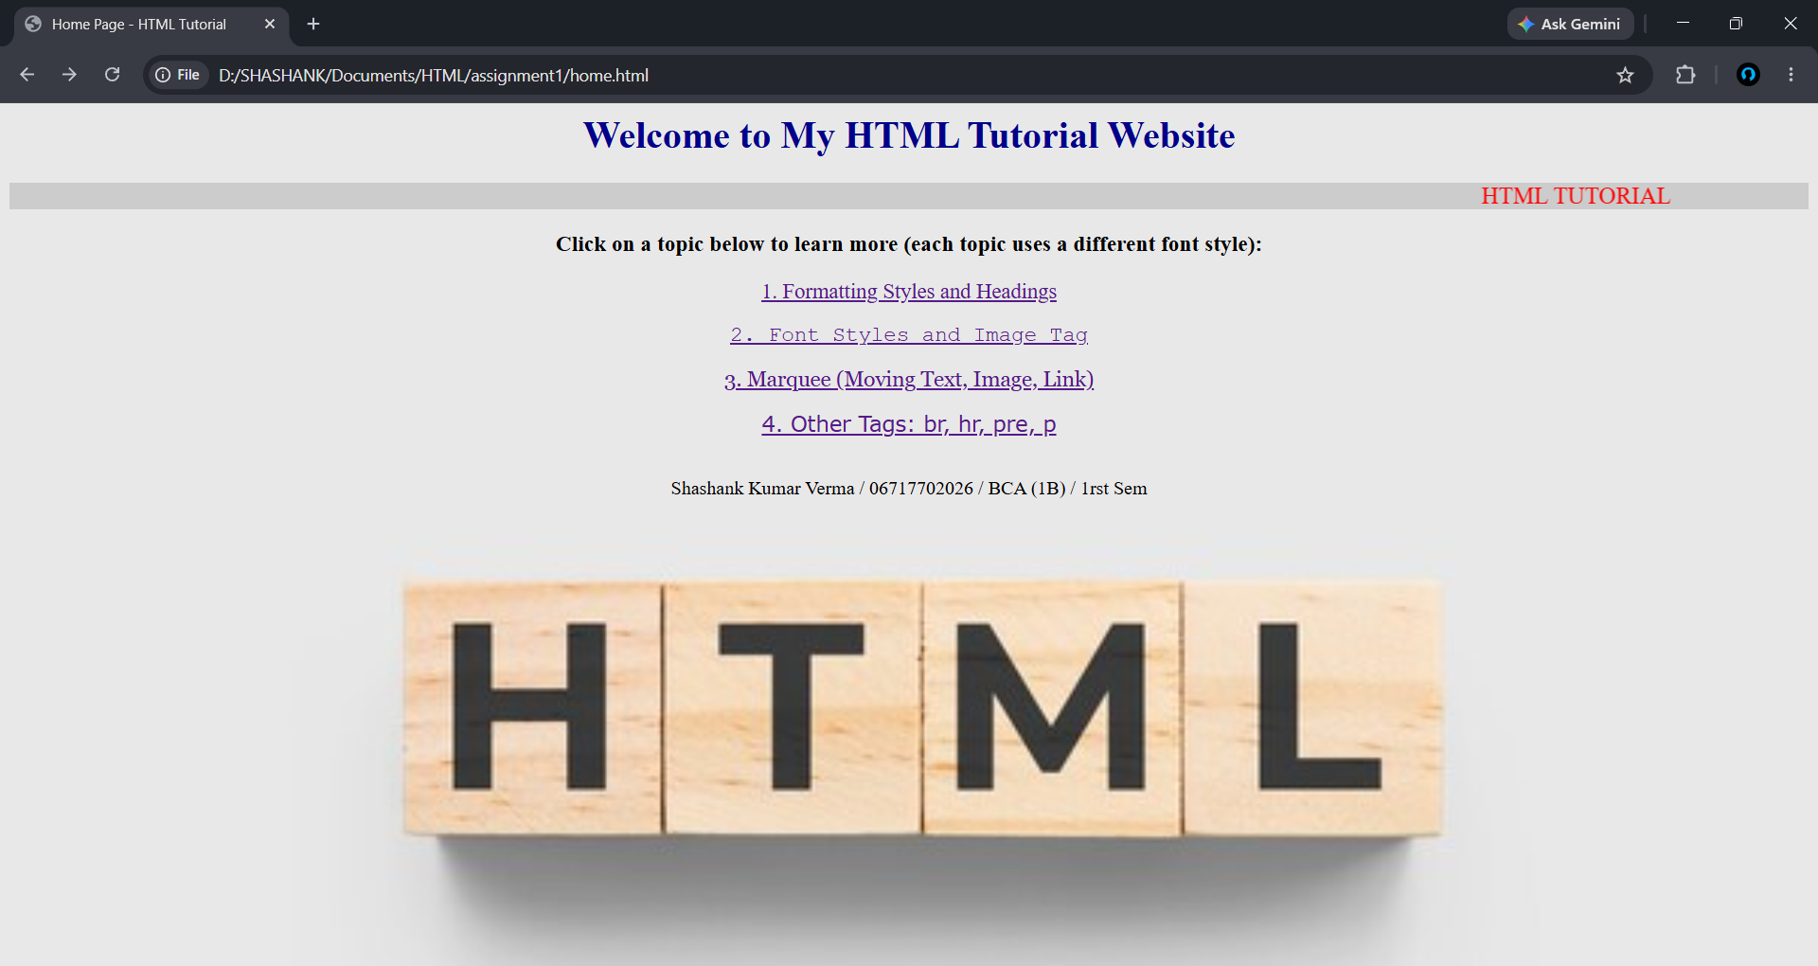
Output:

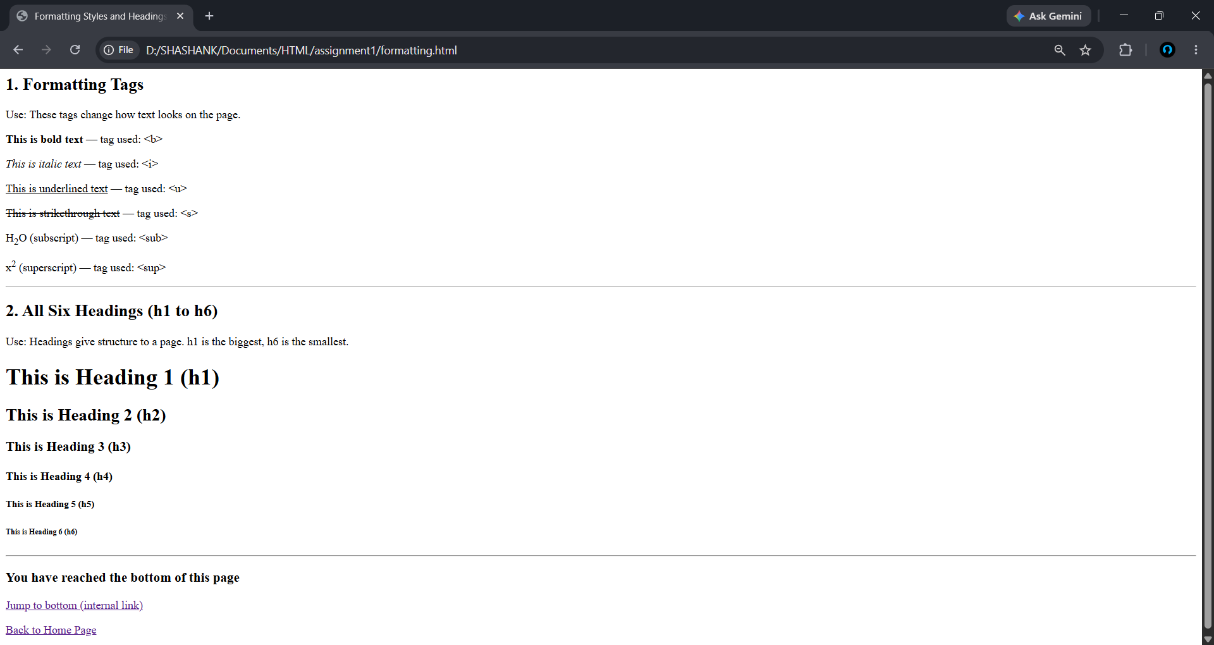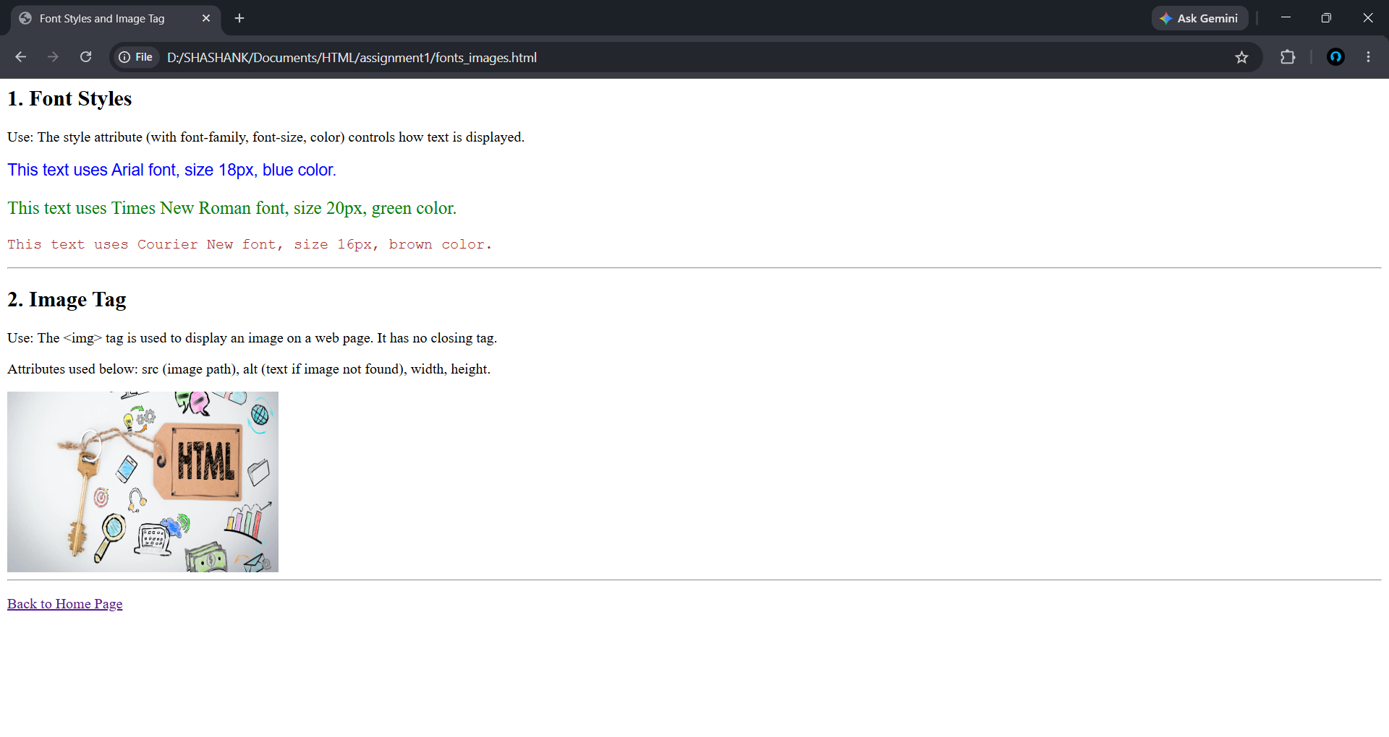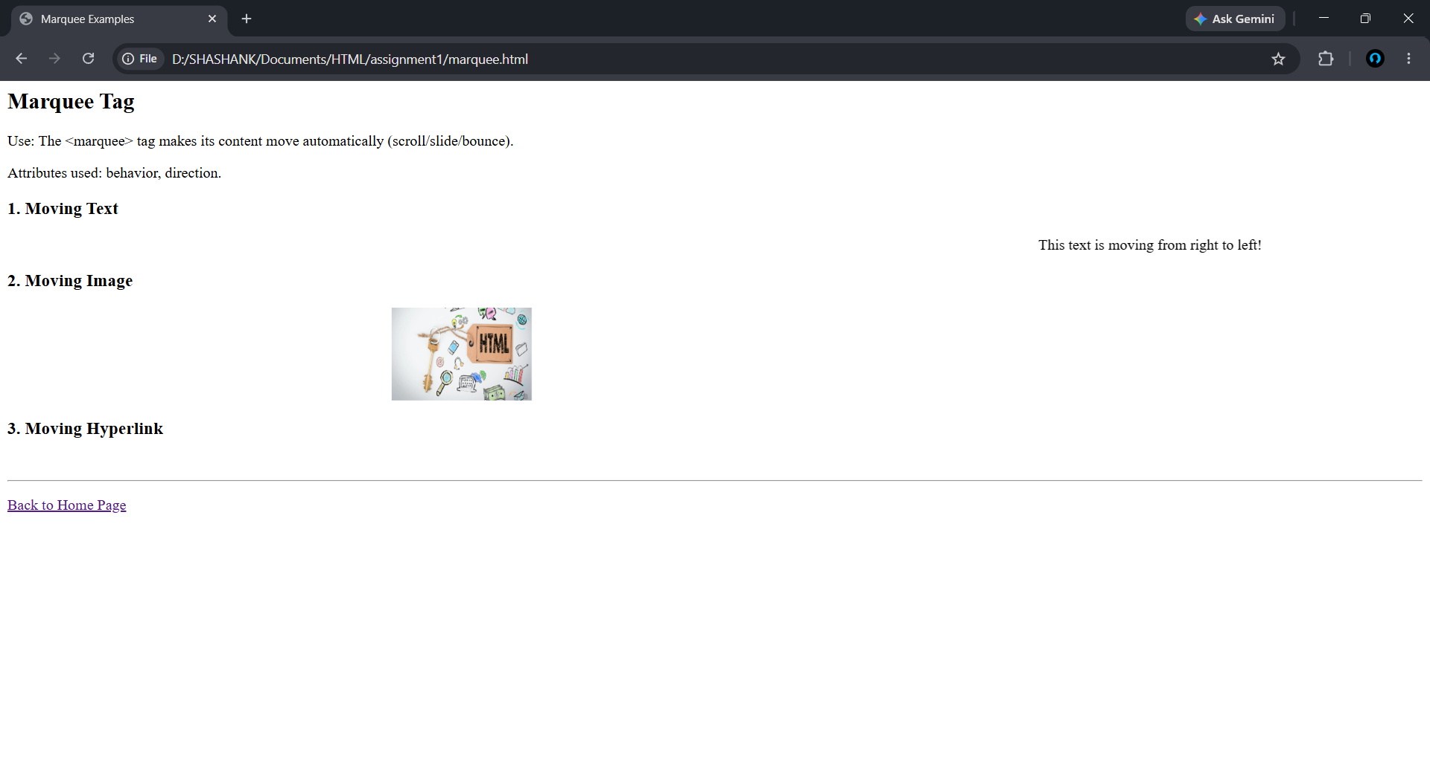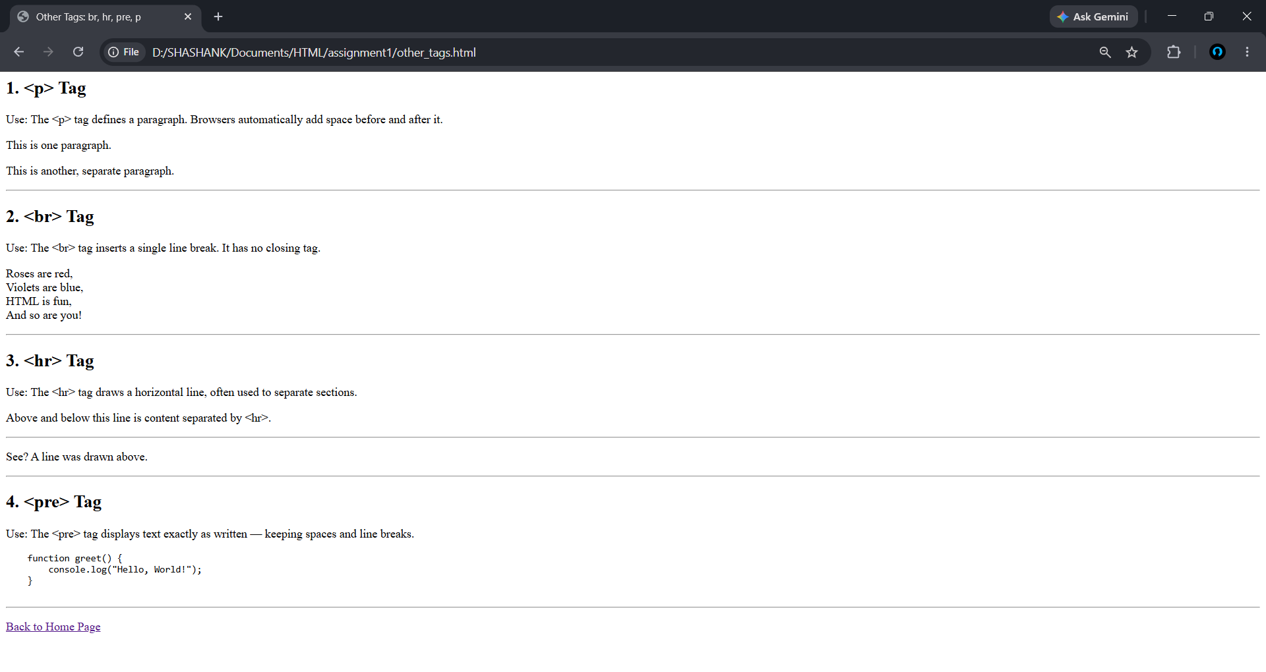

Assignment No.: 2

assignment2/
└── index.html

Source Code:

<!-- index.html -->
<html>

<head>
<title>Assignment 2</title>
</head>

<body bgcolor="#e6f2ff">

<!-- Image of Main item on top right corner -->
<img src="computer.jpg" alt="Computer" align="right" width="150" height="150">

<!-- Heading as Marquee -->
<marquee behavior="scroll" direction="left" bgcolor="#cccccc">
<h1>BCA Subjects</h1>
</marquee>

<h2>Subjects List</h2>

<ol>
<!-- Different font style and color for ordered list item -->
<li style="font-family:Arial; color:blue;">
Web Technologies
<!-- Unordered list nested inside ordered list -->
<ul>
<li>HTML</li>
<li>CSS</li>
</ul>
</li>
<hr>

<li style="font-family:'Times New Roman'; color:green;">
Programming Languages
<ul>
<li>C Language</li>
<li>C++</li>
</ul>
</li>
<hr>

<li style="font-family:'Courier New'; color:red;">
Database Management
<ul>
<li>MySQL</li>
<li>Oracle</li>
</ul>
</li>
<hr>
</ol>

<p><br>Shashank Kumar Verma / 06717702026 / BCA (1B) / 1rst Sem</p>

</body>

</html>

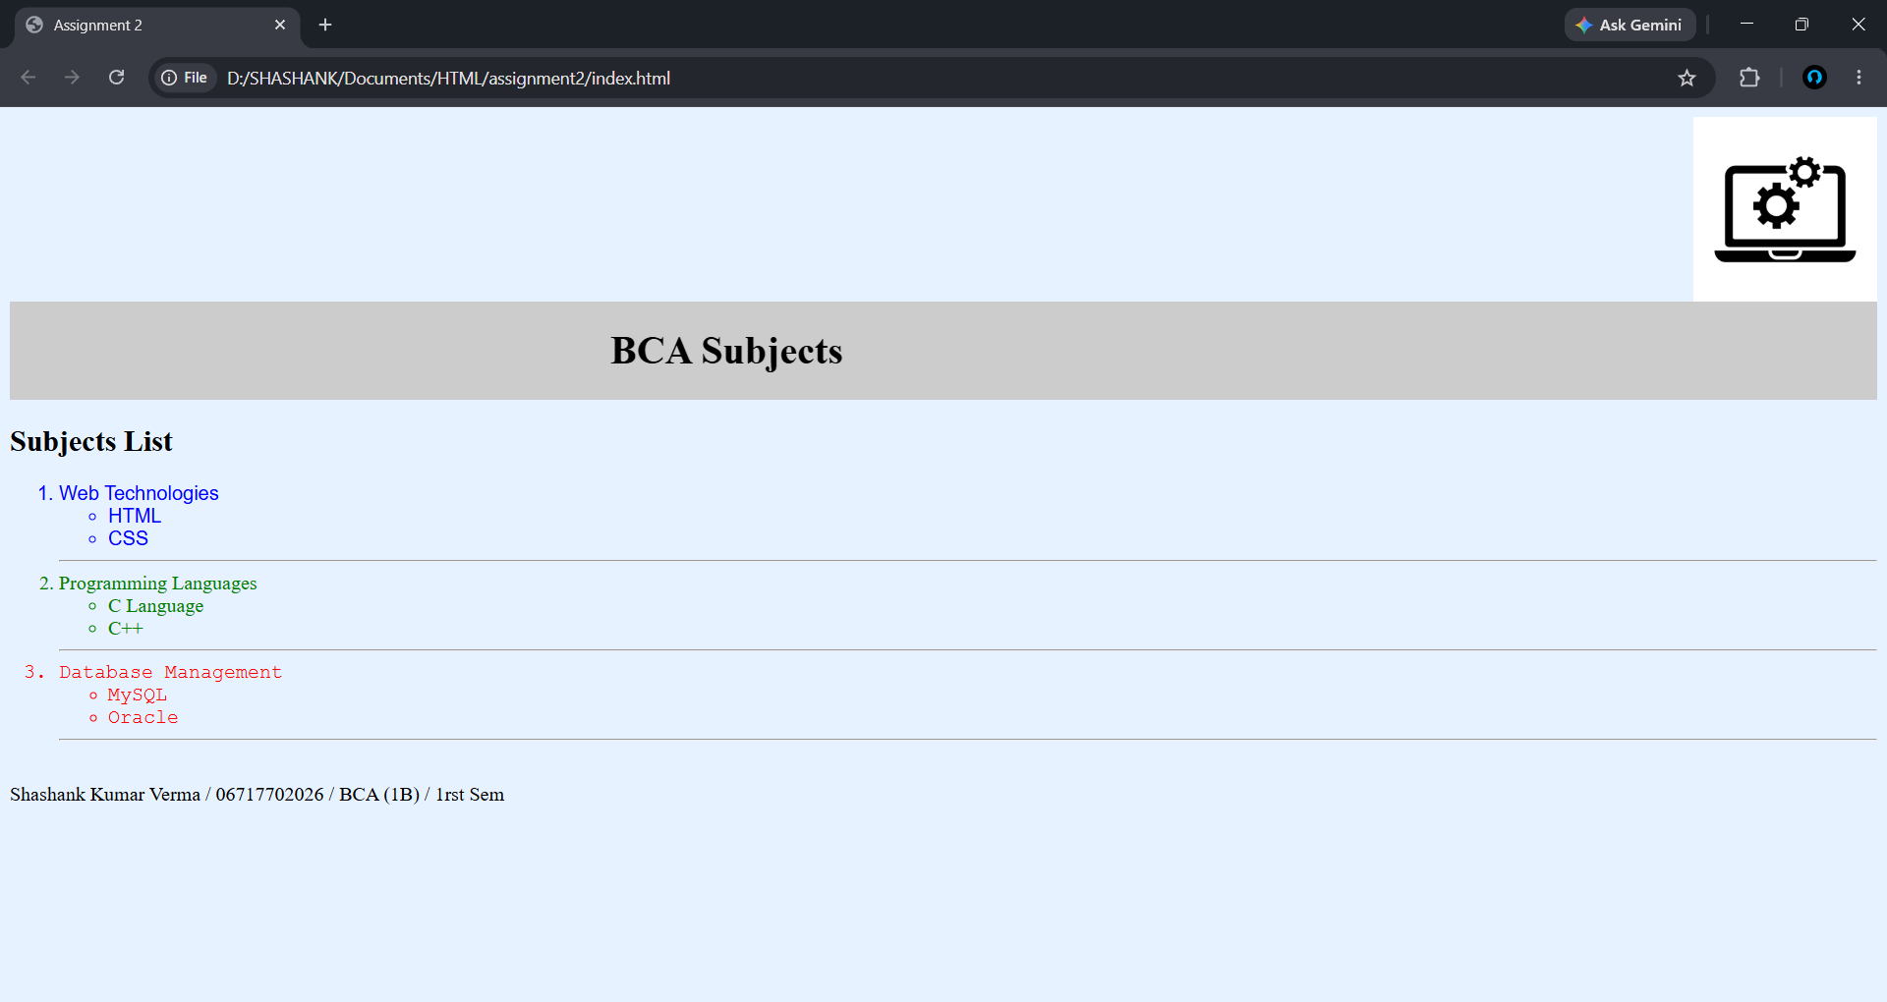
Output:

Assignment No.: 3

assignment3/
└── index.html

Source Code:

<!-- index.html -->
<html>
<head>
<title>Assignment 3 - Table</title>
</head>
<body bgcolor="#f9f9f9">

<h2 align="center">Assignment 3: Student Marks Table</h2>

<!-- Table with row span, column span, width, height, cellpadding, cellspacing -->
<table border="1" width="80%" height="200" cellpadding="10" cellspacing="5" align="center" bgcolor="white">
<tr bgcolor="#cccccc">
<th rowspan="2">Student Name</th>
<th colspan="3">Subject Marks</th>
</tr>
<tr bgcolor="#eeeeee">
<th>HTML</th>
<th>C Language</th>
<th>Maths</th>
</tr>
<tr>
<td align="center">Shashank</td>
<td align="center">90</td>
<td align="center">85</td>
<td align="center">95</td>
</tr>
<tr>
<td align="center">Rahul</td>
<td align="center">88</td>
<td align="center">80</td>
<td align="center">92</td>
</tr>
</table>

<p align="center"><br>Shashank Kumar Verma / 06717702026 / BCA (1B) / 1rst Sem</p>

</body>
</html>

Output:

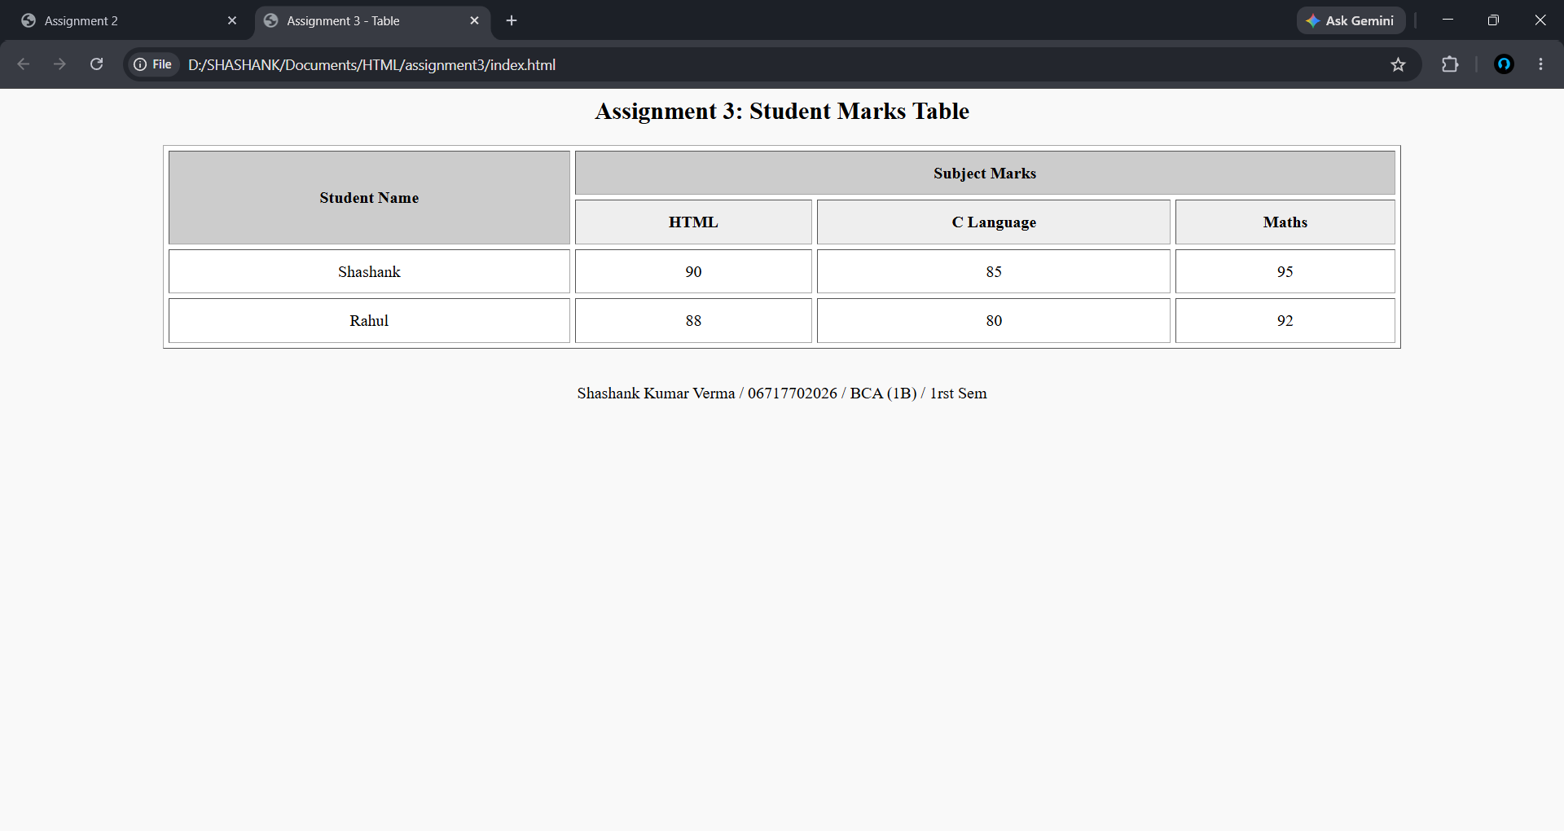

Assignment No.: 4

assignment4/
├── index.html
├── top.html
├── menu.html
├── topic1.html
├── topic1_ex.html
├── topic2.html
├── topic2_ex.html
├── topic3.html
├── topic3_ex.html
├── empty_ex.html
├── empty_exp.html

Source Code:

<!-- index.html -->
<html>
<frameset rows="15%, 85%">
<frame src="top.html" name="title_frame">
<frameset cols="25%, 75%">
<frame src="menu.html" name="menu">
<frameset rows="50%, 50%">
<frame src="empty_exp.html" name="explanation">
<frame src="empty_ex.html" name="example">
</frameset>
</frameset>
</frameset>
</html>

<!-- top.html -->
<html>

<body>
<center>
<h2>About COVID 19</h2>
<p align="center">Shashank Kumar Verma / 06717702026 / BCA (1B) / 1rst Sem</p>
</center>
</body>

</html>

<!-- menu.html -->
<html>
<body>
<h3>MAIN MENU</h3>
<p><a href="topic1.html" target="explanation" onclick="parent.example.location='empty_ex.html'">Topic 1: Covid-19</a></p>
<p><a href="topic2.html" target="explanation" onclick="parent.example.location='empty_ex.html'">Topic 2: India</a></p>
<p><a href="topic3.html" target="explanation" onclick="parent.example.location='empty_ex.html'">Topic 3: Precautions</a></p>
</body>
</html>

<!-- topic1.html -->
<html>
<body>
<h3>Explanation</h3>
<hr>
<p>Coronavirus disease is an infectious disease caused by the SARS-CoV-2 virus.</p>
<p>Viruses constantly change through mutation, leading to variants.</p>
<a href="topic1_ex.html" target="example">View Example</a>
</body>
</html>

<!-- topic2.html -->
<html>
<body>
<h3>Explanation</h3>
<hr>
<p>India faced multiple waves of Covid-19.</p>
<p>The vaccination drive in India was one of the largest globally.</p>
<a href="topic2_ex.html" target="example">View Example</a>
</body>
</html>

<!-- topic3.html -->
<html>
<body>
<h3>Explanation</h3>
<hr>
<p>To prevent infection and slow transmission, follow public health guidelines.</p>
<p>Simple precautions can protect yourself and others.</p>
<a href="topic3_ex.html" target="example">View Example</a>
</body>
</html>

<!-- topic1_ex.html -->
<html>
<body>
<h3>Example</h3>
<hr>
<p><b>Delta Variant:</b> First identified in India, it was significantly more contagious.</p>
</body>
</html>
<!-- topic2_ex.html -->
<html>
<body>
<h3>Example</h3>
<hr>
<p><b>Co-WIN:</b> The digital platform launched to administer billions of vaccine doses.</p>
</body>
</html>

<!-- topic3_ex.html -->
<html>
<body>
<h3>Example</h3>
<hr>
<ul>
<li>Wear a mask</li>
<li>Maintain social distancing</li>
</ul>
</body>
</html>

<!-- empty_exp.html -->
<html>
<body>
<h3>Explanation</h3>
<hr>
<p>Choose your topic.</p>
</body>
</html>

<!-- empty_ex.html -->
<html>
<body>
<h3>Example</h3>
<hr>
</body>
</html>

Output:

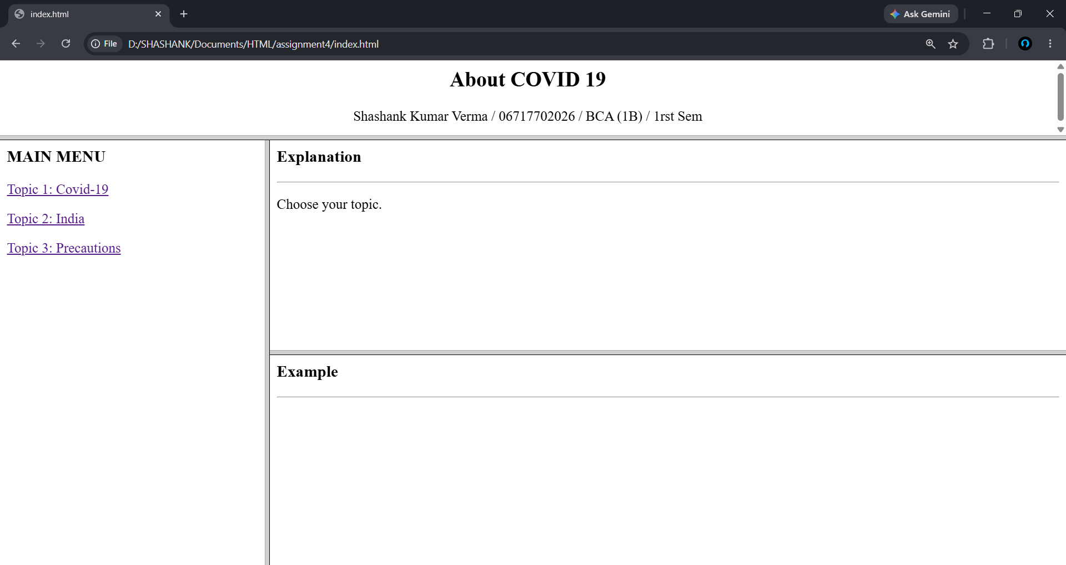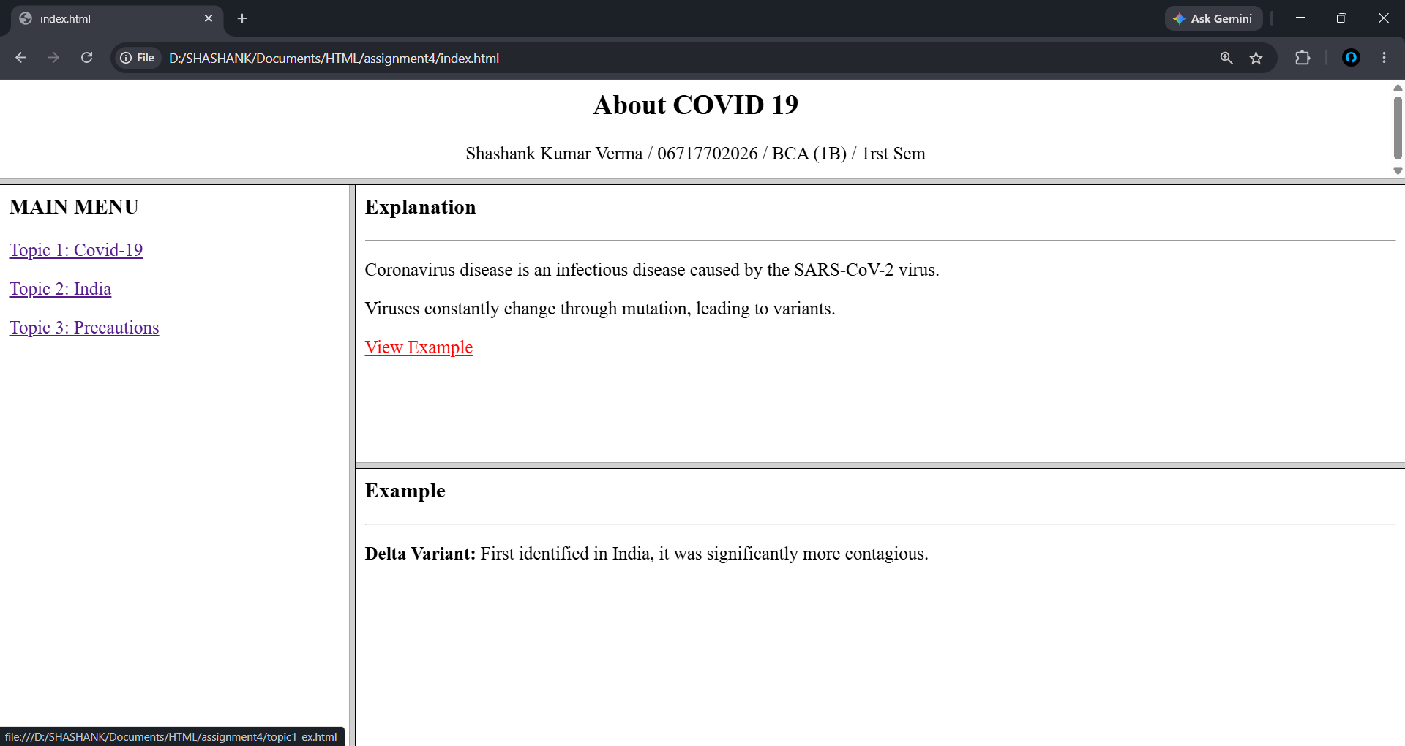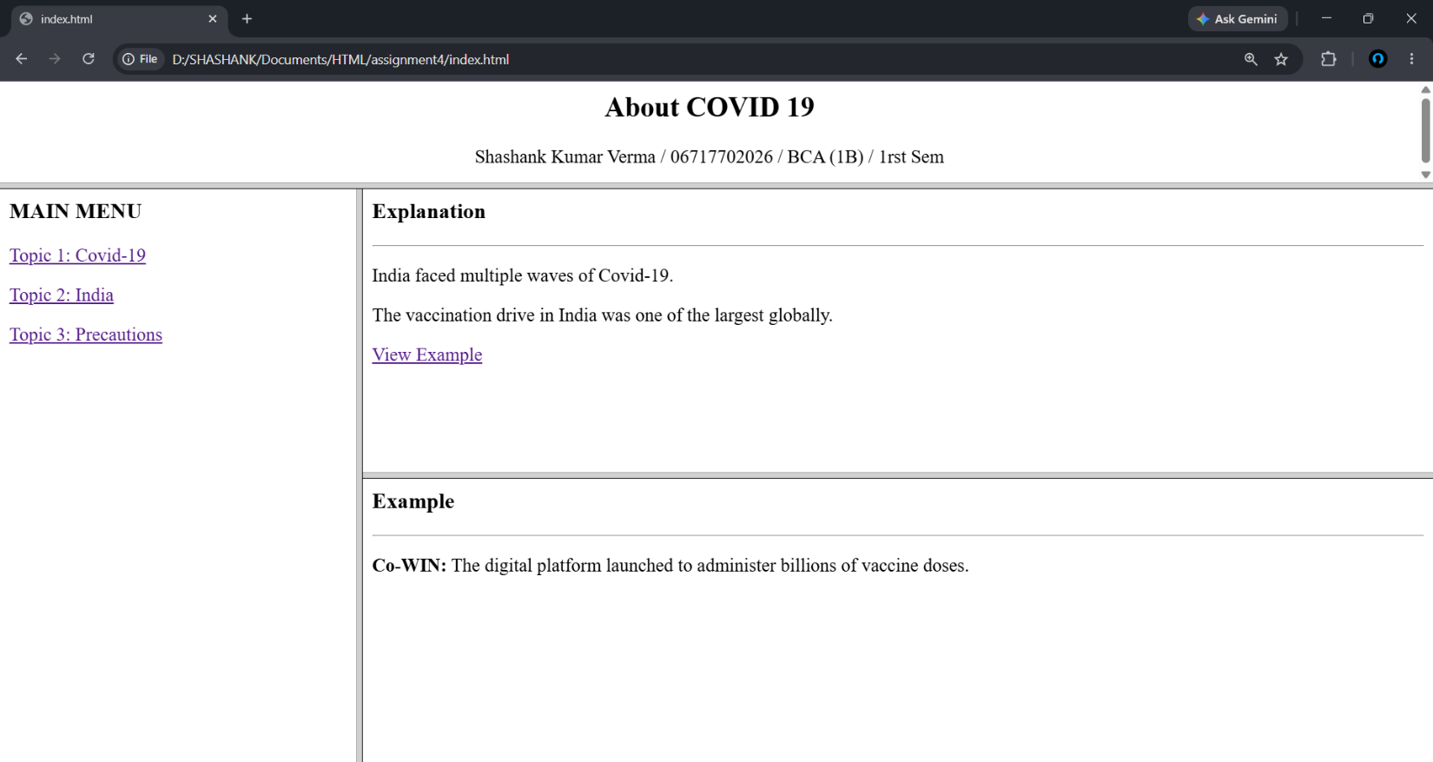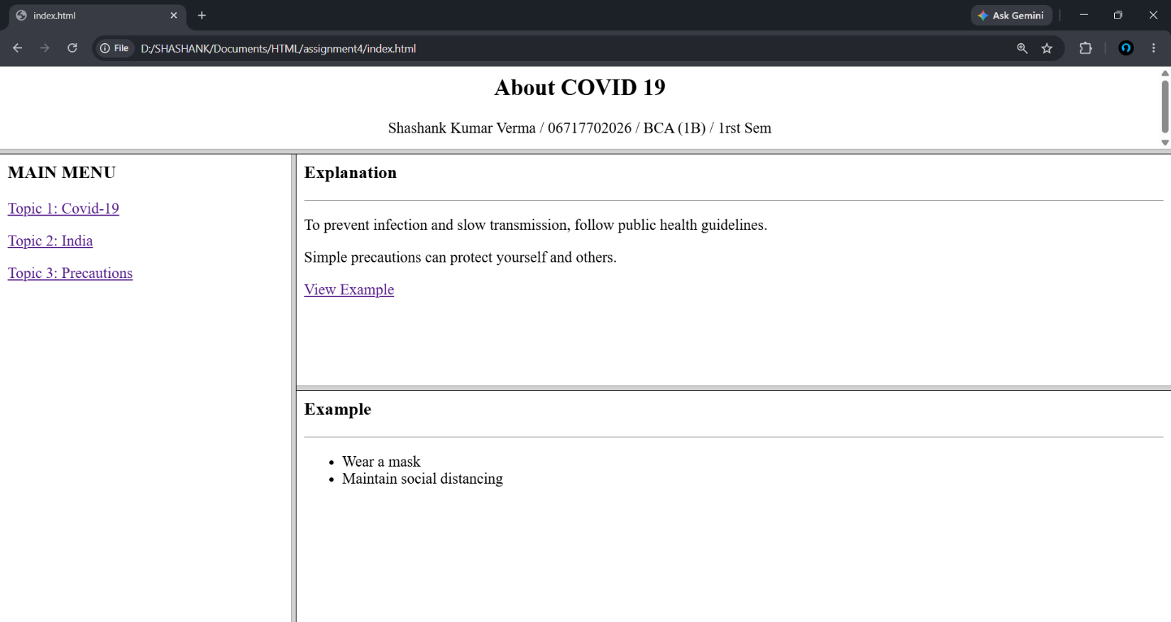
Assignment No.: 5

assignment5/
├── circle.html
├── index.html
├── rectangle.html
├── square.html
└── triangle.html

Source Code:

<!-- circle.html -->
<html>

<head>
<title>Circle - Details</title>
</head>

<body>
<img src="circle.jpg" alt="Circle" width="25%">
<br><br>
<ul>
<li>A circle is a round shape with no corners or edges.</li>
<li>In geometry, a circle is a closed two-dimensional figure.</li>
<li>All points on the boundary are equidistant from the center.</li>
<li>The distance from the center to the edge is called the radius.</li>
<li>The line segment through the center connecting two boundary points is the diameter.</li>
</ul>
<br>
<a href="index.html"><b>Back to Main Map</b></a>
</body>

</html>

<!-- rectangle.html -->
<html>

<head>
<title>Rectangle - Details</title>
</head>

<body>
<img src="rectangle.jpg" alt="Rectangle" width="25%">
<br><br>
<ul>
<li>A rectangle is a quadrilateral with four right angles.</li>
<li>Opposite sides of a rectangle are parallel and equal in length.</li>
<li>The diagonals bisect each other and are of equal length.</li>
<li>It is a special case of a parallelogram.</li>
<li>A square is a special type of rectangle where all sides are equal.</li>
</ul>
<br>
<a href="index.html"><b>Back to Main Map</b></a>
</body>
</html>

<!-- square.html -->
<html>

<head>
<title>Square - Details</title>
</head>

<body>
<img src="square.jpg" alt="Square" width="25%">
<br><br>
<ul>
<li>A square is a regular quadrilateral.</li>
<li>It has four equal sides and four equal angles.</li>
<li>Each internal angle is a right angle (90 degrees).</li>
<li>The opposite sides are parallel.</li>
<li>The diagonals are equal in length and bisect each other at right angles.</li>
</ul>
<br>
<a href="index.html"><b>Back to Main Map</b></a>
</body>
</html>

<!-- triangle.html -->
<html>

<head>
<title>Triangle - Details</title>
</head>

<body>
<img src="triangle.jpg" alt="Triangle" width="25%">
<br><br>
<ul>
<li>A triangle is a polygon with three edges and three vertices.</li>
<li>It is one of the basic shapes in geometry.</li>
<li>The sum of the internal angles of a triangle is always 180 degrees.</li>
<li>Triangles can be classified by their sides (equilateral, isosceles, scalene).</li>
<li>They can also be classified by their angles (acute, right, obtuse).</li>
</ul>
<br>
<a href="index.html"><b>Back to Main Map</b></a>
</body>
</html>

Output:

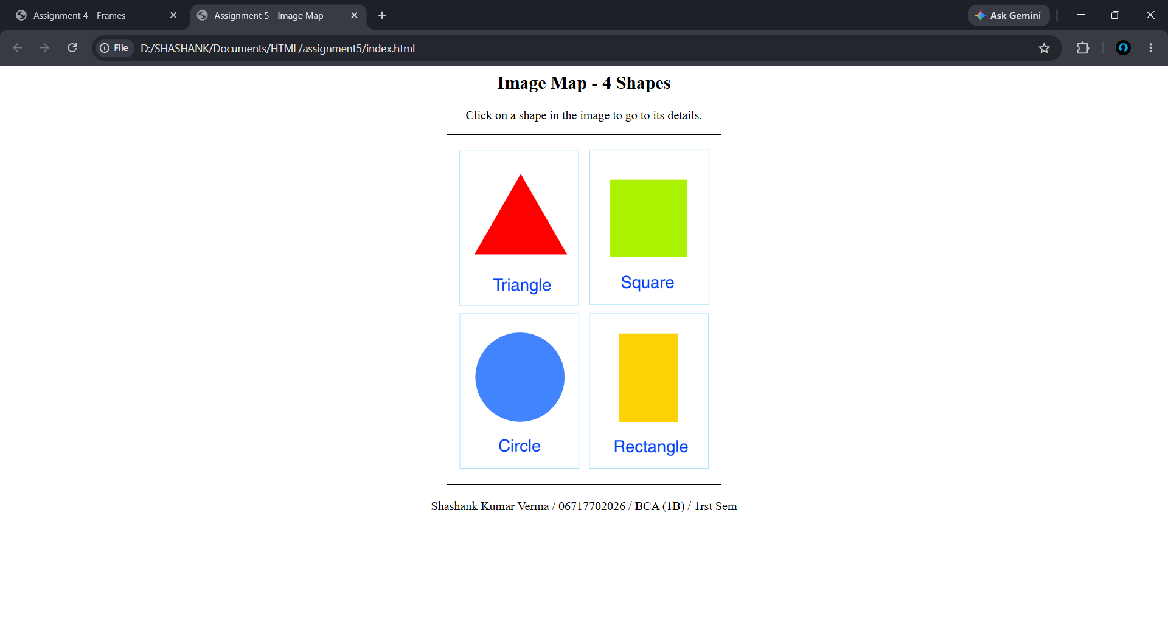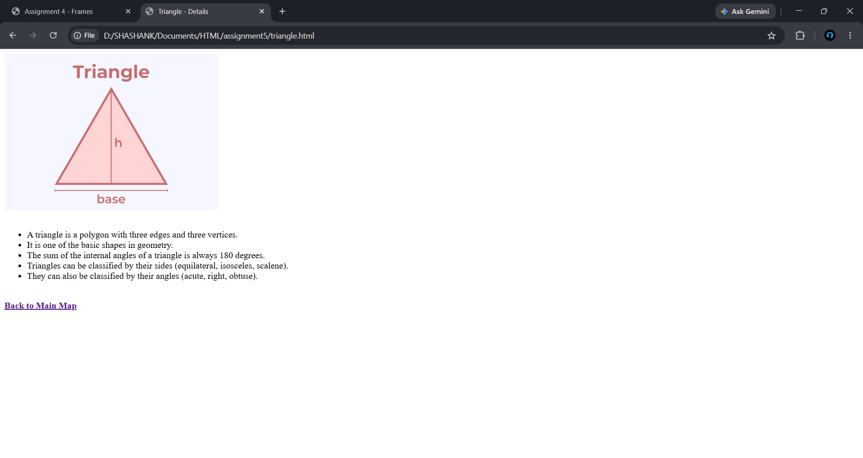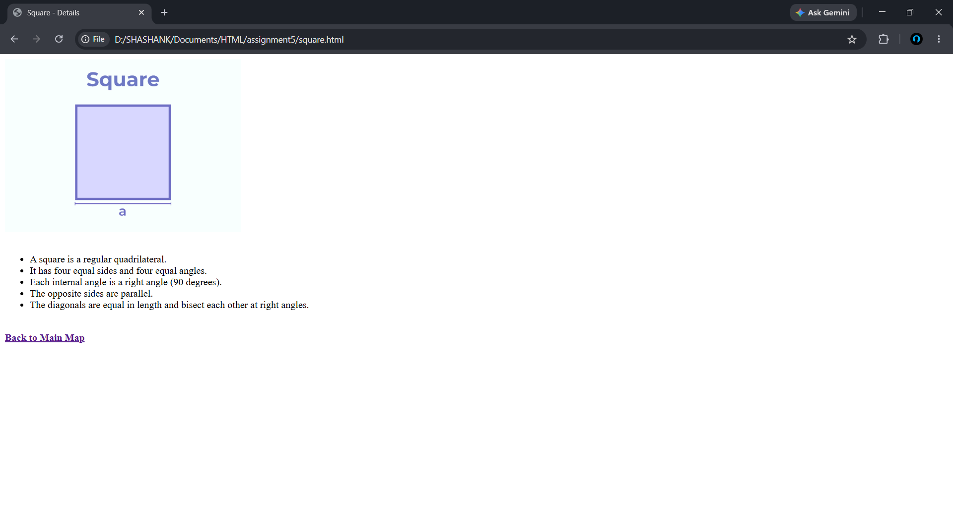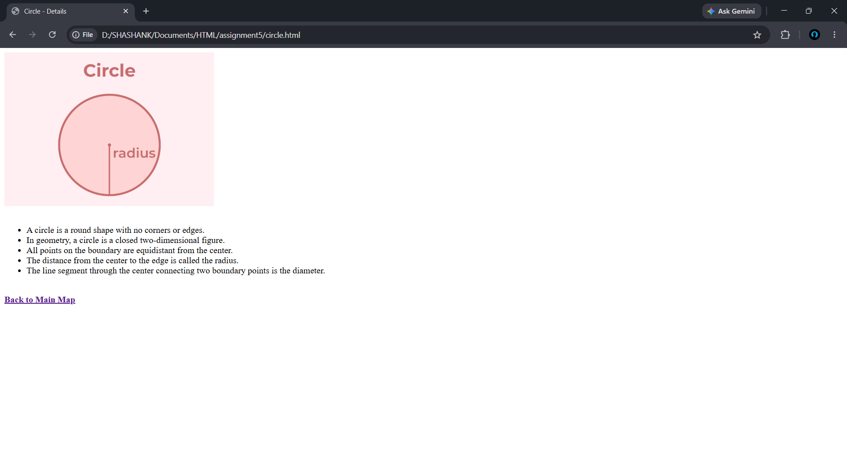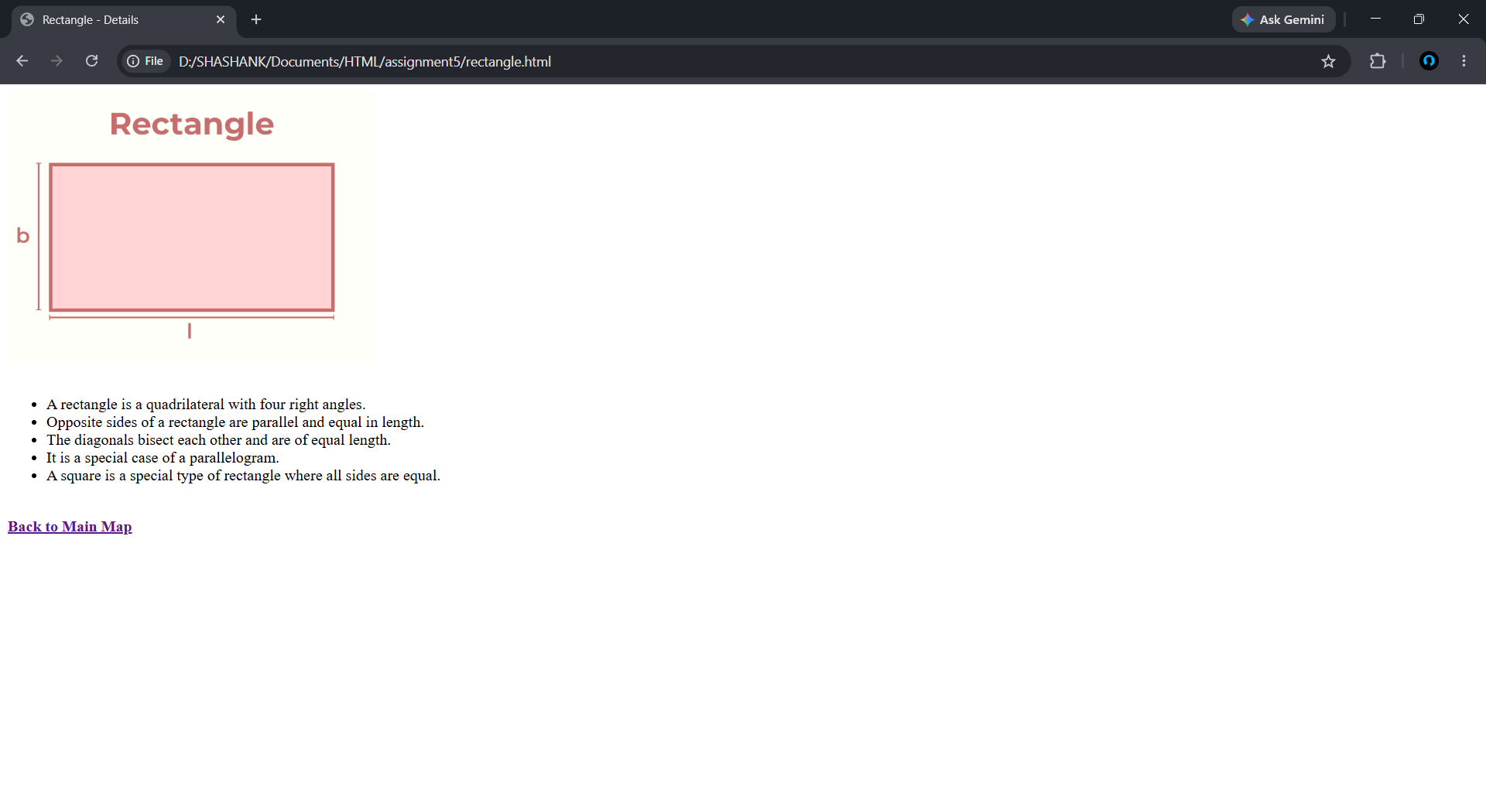

Assignment No.: 6

assignment6/
└── index.html

Source Code:

<!-- index.html -->
<html>
<head>
<title>Assignment 6 - Registration Form</title>
</head>
<body bgcolor="#f5f5dc">
<h2 align="center">Student Registration Form for Admission</h2>

<form align="center">
<table border="0" align="center">
<tr>
<td>Student Name:</td>
<td><input type="text" name="sname" size="25"></td>
</tr>
<tr>
<td>Father's Name:</td>
<td><input type="text" name="fname" size="25"></td>
</tr>
<tr>
<td>Gender:</td>
<td>
<input type="radio" name="gender" value="Male"> Male
<input type="radio" name="gender" value="Female"> Female
</td>
</tr>
<tr>
<td>Course Applied:</td>
<td>
<select name="course">
<option value="BCA">BCA</option>
<option value="BBA">BBA</option>
<option value="B.Com">B.Com</option>
</select>
</td>
</tr>
<tr>
<td>Date of Birth:</td>
<td><input type="date" name="dob"></td>
</tr>
<tr>
<td>Address:</td>
<td><textarea name="address" rows="4" cols="25"></textarea></td>
</tr>
<tr>
<td colspan="2" align="center">
<br>
<input type="submit" value="Submit Form">
<input type="reset" value="Clear Form">
</td>
</tr>
</table>
</form>

<p align="center"><br>Shashank Kumar Verma / 06717702026 / BCA (1B) / 1rst Sem</p>

</body>
</html>

Output:

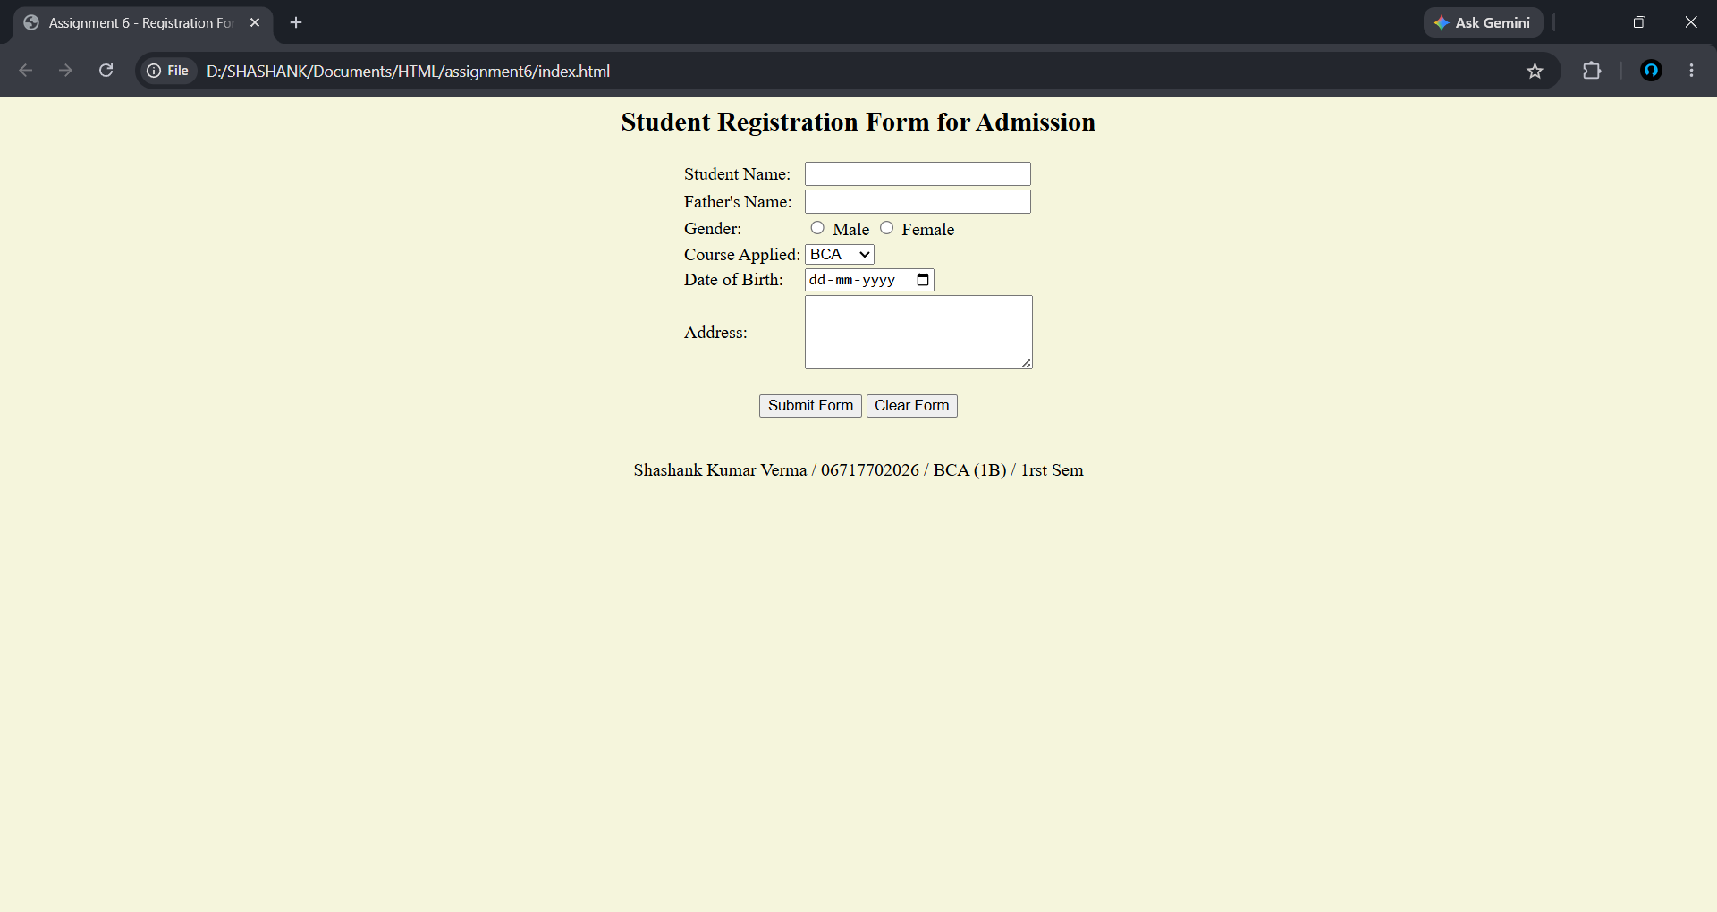

Assignment No.: 7

assignment7/
├── index.html
└── style.css

Source Code:

/* style.css */
/* External Stylesheet for Assignment 7 */
.external-style {
color: red;
font-family: Arial;
text-align: center;
text-decoration: underline;
}

<!-- index.html -->
<html>

<head>
<title>Assignment 7 - Stylesheets</title>
<!-- External Stylesheet -->
<link rel="stylesheet" type="text/css" href="style.css">

<!-- Internal Stylesheet (kept as assignment demonstrates all 3 types) -->
<style>
.internal-style {
color: green;
font-size: 20px;
font-weight: bold;
}
</style>
</head>

<body bgcolor="#fdf5e6">

<h2 class="external-style">This heading uses External Stylesheet</h2>

<p class="internal-style">This paragraph uses Internal Stylesheet.</p>

<!-- Inline Stylesheet -->
<p style="color:blue; font-family:'Courier New'; font-size:18px;">
This paragraph uses Inline Stylesheet.
</p>

<p>Shashank Kumar Verma / 06717702026 / BCA (1B) / 1rst Sem</p>

</body>
</html>
Output:

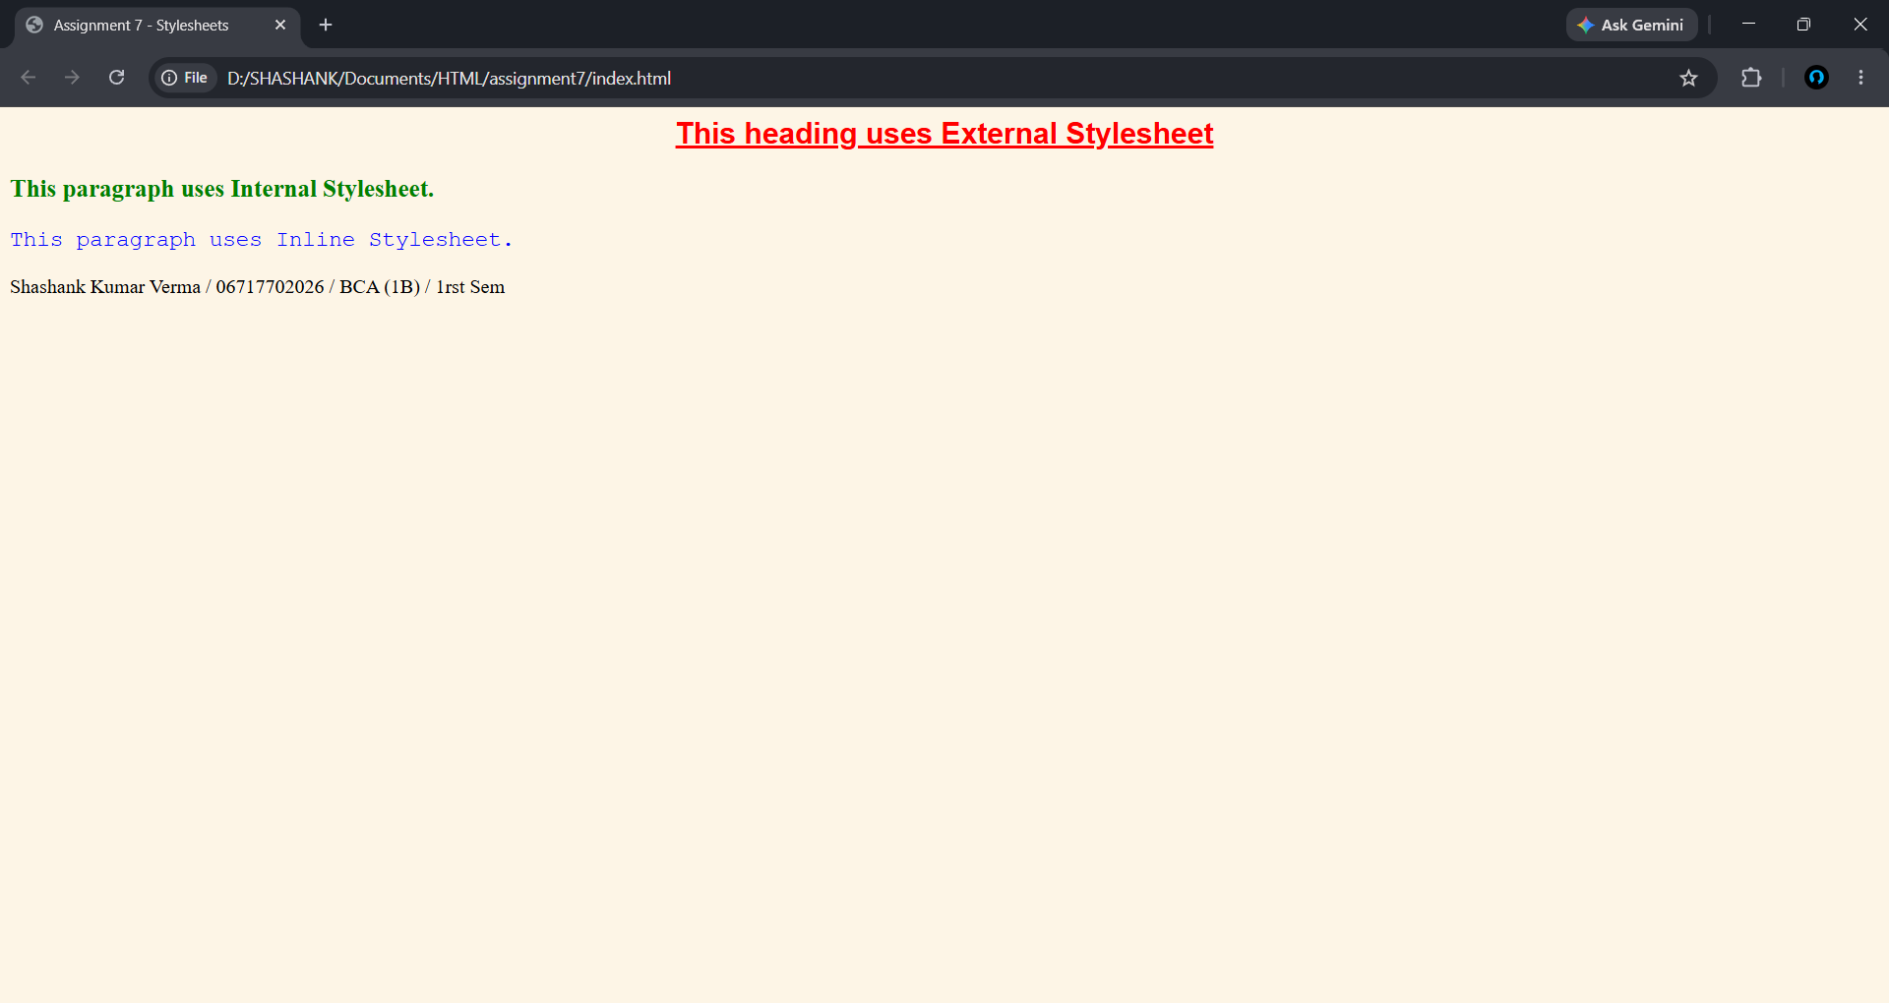

Assignment No.: 8

assignment8/
├── index.html
├── bg.jpg
├── nature.jpg
└── tile.png

Source Code:

<!-- index.html -->
<html>

<head>
<title>Assignment 8 - Background Styling</title>
<style>
body {
font-family: Arial;
padding: 10px;
}

.box {
border: 2px solid #555;
height: 120px;
margin-bottom: 16px;
padding: 10px;
}

.label {
background-color: rgba(255, 255, 255, 0.82);
padding: 4px 8px;
display: inline-block;
}
</style>
</head>

<body>

<h2 align="center">Assignment 8: Background Styling Attributes</h2>
<hr>

<!-- 1. background-color -->
<div class="box" style="background-color: steelblue;">
<span class="label"><b>1. background-color: steelblue</b><br>
Sets a solid color as background. No image needed.</span>
</div>

<!-- 2. background-image — default (repeats) -->
<div class="box" style="background-image: url('tile.png');">
<span class="label"><b>2. background-image (default repeat)</b><br>
Small tile image repeats to fill entire area.</span>
</div>

<!-- 3. background-repeat: no-repeat -->
<div class="box" style="background-image: url('nature.jpg'); background-repeat: no-repeat; background-color: #ccc;">
<span class="label"><b>3. background-repeat: no-repeat</b><br>
Image appears only once. Gray fills the rest.</span>
</div>

<!-- 4. background-repeat: repeat-x -->
<div class="box" style="background-image: url('tile.png'); background-repeat: repeat-x; background-color: #eee;">
<span class="label"><b>4. background-repeat: repeat-x</b><br>
Image repeats horizontally only (one row along the top).</span>
</div>

<!-- 5. background-repeat: repeat-y -->
<div class="box" style="background-image: url('tile.png'); background-repeat: repeat-y; background-color: #eee;">
<span class="label"><b>5. background-repeat: repeat-y</b><br>
Image repeats vertically only (one column on the left).</span>
</div>

<!-- 6. background-position -->
<div class="box"
style="background-image: url('nature.jpg'); background-repeat: no-repeat; background-position: center center; background-color: #aaa;">
<span class="label"><b>6. background-position: center center</b><br>
Image is placed exactly at the center of the box.</span>
</div>

<!-- 7. background-size: cover -->
<div class="box" style="background-image: url('nature.jpg'); background-size: cover;">
<span class="label"><b>7. background-size: cover</b><br>
Image scales to fully cover the box. No gaps, may crop.</span>
</div>

<!-- 8. background-size: contain -->
<div class="box"
style="background-image: url('nature.jpg'); background-size: contain; background-repeat: no-repeat; background-color: #bbb;">
<span class="label"><b>8. background-size: contain</b><br>
Image fits fully inside the box. Gray fills gaps.</span>
</div>

<!-- 9. background-attachment: fixed -->
<div class="box" style="background-image: url('nature.jpg'); background-size: cover; background-attachment: fixed;">
<span class="label"><b>9. background-attachment: fixed</b><br>
Background stays fixed when page is scrolled down.</span>
</div>

<!-- 10. All properties combined -->
<div class="box"
style="background-image: url('nature.jpg'); background-color: #336; background-repeat: no-repeat; background-position: right bottom; background-size: 40%;">
<span class="label"><b>10. All combined</b><br>
image at right-bottom, 40% size, no-repeat, color fills rest.</span>
</div>

<hr>
<p align="center">Shashank Kumar Verma / 06717702026 / BCA (1B) / 1rst Sem</p>
</body>
</html>
Output:
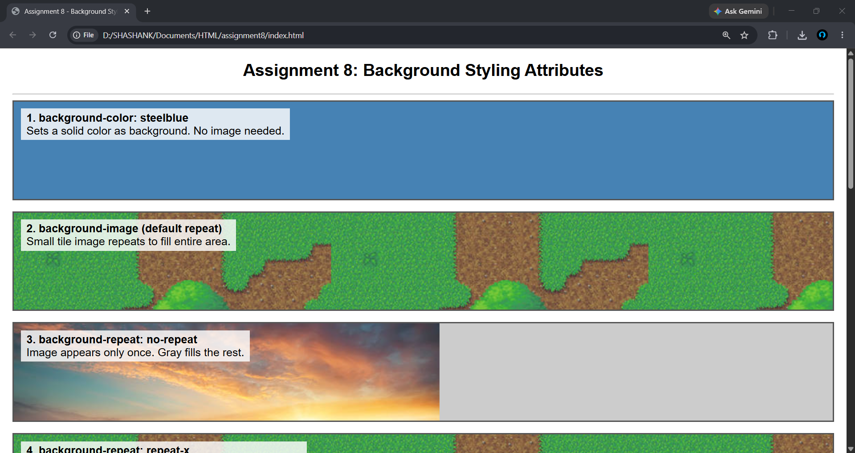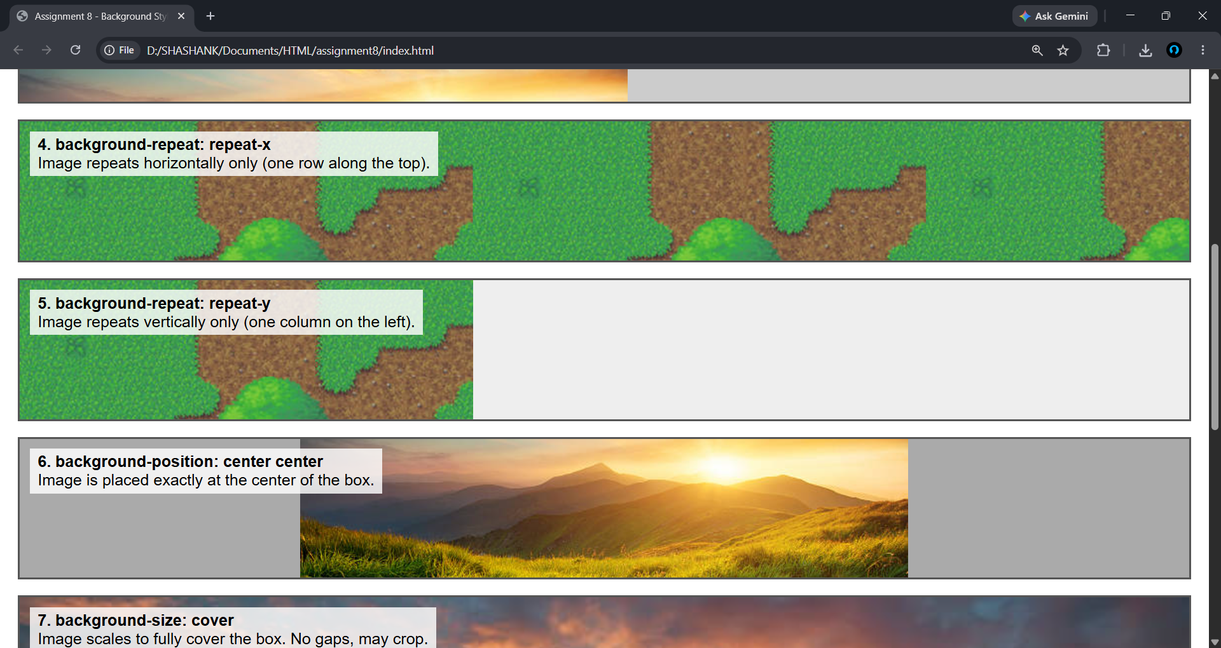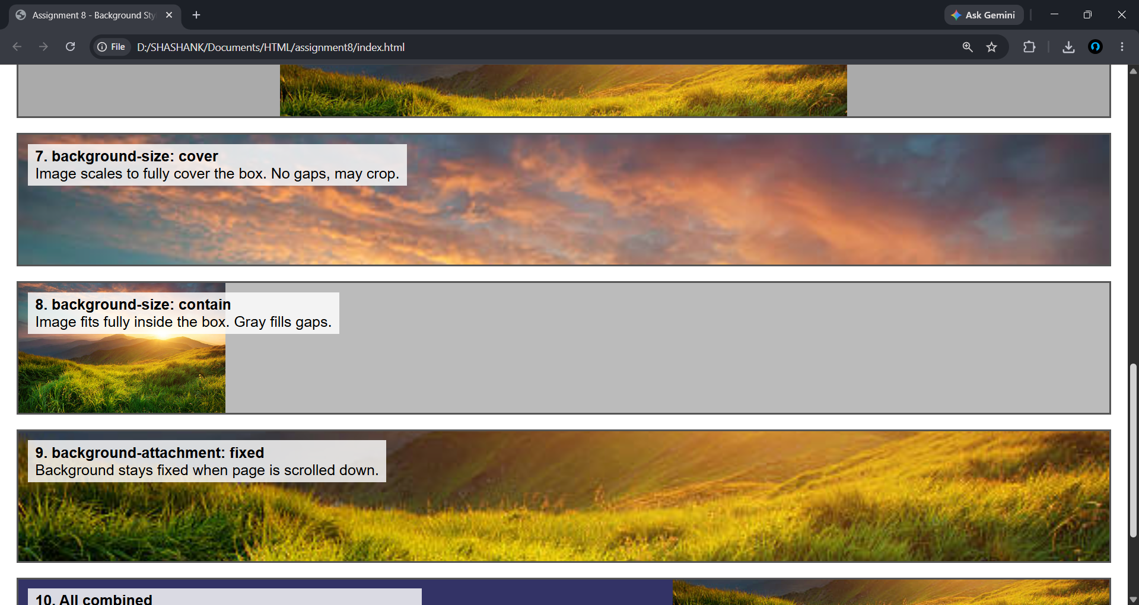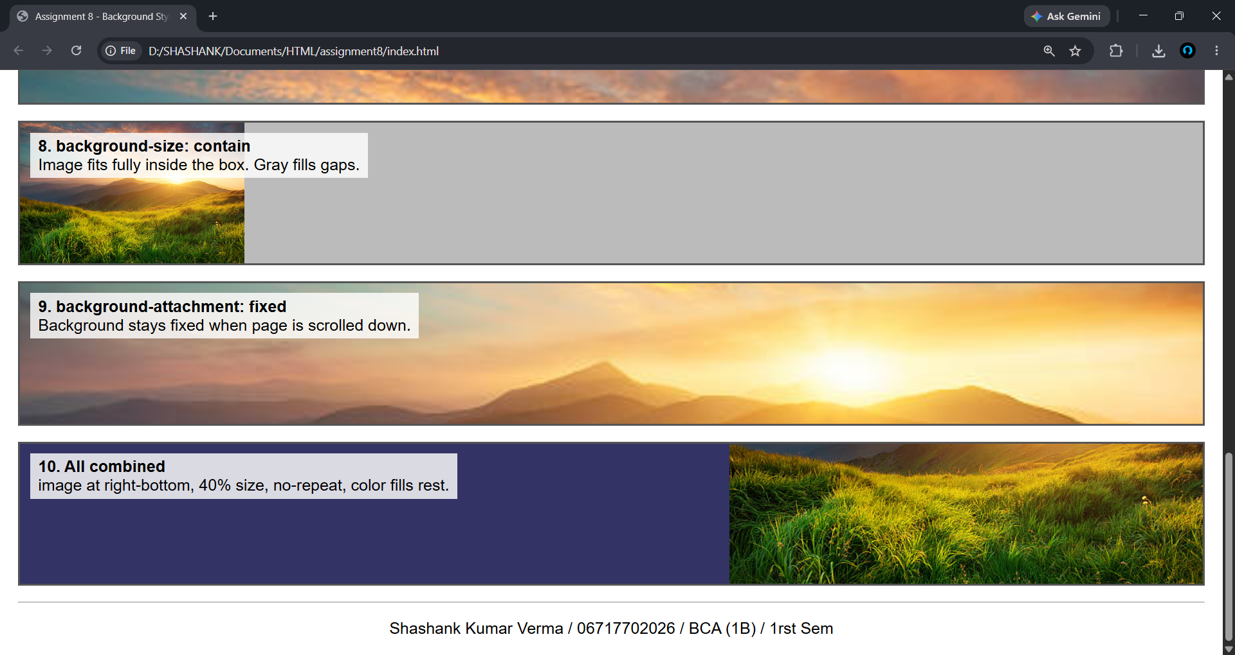

Instructions
Copy and Paste the source code of assignment 1 from the notepad.
For formatting:
Font size - 12
Font face - Times New Roman
Paragraph spacing: 1, single

Followed by the output.

Output:
Screenshots to be attached for the output

And so on for the next assignment
New assignment will always starts with the new page

